

**Summer Holiday Homework 2025-26**

**Class-VIII**

**Subject-English**

Q-1 Define parts of speech with their kinds

Q-2 Define the following of sentences with their examples

1. Declarative (iii) Interrogative
2. Imperative (iv) Exclamatory

Q- 3 Answer the following Comprehension passage carefully

1. (Passage ./ no. ( 1) Rikki – tikki- tavi . ( Page. No 171) in English Grammar
2. ( Passage / no. (2) Born again ( page. No 175) in English Grammar book .

Q- 4 Write the following applications

1. One day leave. (ii) Urgent piece of work (iii) Sick leave.

Q-5 Write an informal letter to your friend describing your school trip to a museum.

**Subject-Hindi**

(1) निम्नलिखित विषयों पर सचित्र अनुच्छेद लिखिए-

(i) पेड़ बचाओ (ⅱ) मोबाइल के प्रभाव

(ⅲ) पहाड़ी स्थान की यात्रा (iv) बाल मजदूरी

(2) ग्रीष्म कालीन अवकाश बिताने की योजना बताते हुए दादा जी को एक पत्र लिखिए ।

(3) किन्ही दस लोकोक्तियों का अर्थ लिखकर वाक्य प्रयोग कीजिए।(पेज नं०177)

4 - कवीर दास जी का सुंदर चित्र बनाकर उनके पाँच दोहे लिखकर एक A-4 Sheet तैयार कीजिए।

**Subject-Sanskrit**

प्र०-1 'क्रीड' अथवा खाद् धातु के रूप लङ्‌ और लोट्‌लकार में याद करके लिखिए। (पृष्ठ संख्या 116)

प्र०-2 दीर्घ सन्धि अथवा गुण सन्धि का पुनः अभ्यास करके किन्ही 15 नये शब्दों के सन्धि विच्छेद कीजिए।

प्र०-3 किन्हीं 15 पर्यायवाची शब्दों का अभ्यास करके लिखिए।

प्र०-4 किन्ही 15 विलोम शब्दों का अभ्यास कीजिए और याद करके कॉपी में लिखिए। **Subject-Mathematics**

Q-1 Write tables 2 to 25

Q-2 Do model question paper 1 on page no 75.

Q-3 Do logical reasoning and aptitude based question on book page no- 262, 263, 264.

Q-4 make a model of any one topic given below.

1. Geometrical
2. Graphical ( Date handling)
3. Pythagoras theorem

**Subject-Science**

**\*Model or Poster (Creative work)-**

Make any one of the following:

Q1) A3D model or drawing of a Bunsen burner flame showing zones (blue, yellow. dark Zone)

Q2 )A poster on conservation of fossil fuels with slogans and tips.

**\* Research and write (Awareness Activity)-**

Write a short article (150-200 words) on:

Q) “Why should we conserve fossil fuels?" Mention alternative energy sources and How you can help at home or school.

**\* Practice Questions-**

Prepare answers to the following

Q1) what is combustion ? Name any three types

Q2) Why is water not used to extinguish petrol bires?

Q3) What is CNG ?why is it Called a clean fuel ?

Q4) Name two advantages and disadvantages of using fossil fuels.

Q5) What is the difference between renewable and non- renewable resources ?

**Subject-S.St**

1- Write about our national movement 's leaders with photo ( Any Five ) file

2- Write the importance things about our nation. (In decorated file)

1 . Population 2 Area 3 Capital

4 Language 5 Density 6 Soils

7 Rivers 8 Mountains 9 Crops

10. National - flower, birds,animal, symbol , anthem, song, tree ,sweet etc

11 Total states and capitals 12 First president of India

13 first women president of india 14 first Pm of india

15 first women pm of india

16 India share its border with other countries

17 The Tropic of cancer Passes through the states ?

18 Total seats in Loksabha

19 Total seats in Rajaysabha

20 Speaker of lok sabha and Rajya sabha

3 fill the map book.

**Page No - 9 ,10,11,13,67,69,71**

**Subject-Computer**

1- Explain the Types of Network topologies with Diagram. (Prepare a 7 Page)

2- Explain the Transmission media with diagram

3- Explain the wireless communication media anal Device used for establishing network

4- Explain the various types of computer virus (prepare a 7 Page)

5- Draw the diagram of computer parts and write their name.

**Subject-G.K**

.1 Make a chart on the topic "Unity in Diversity? (Hint-culture, costume )

2. Write something about five freedom fighters and paste there picture on your notebook.

3. Who is the Present Prime Minister of India Write something about his achievements

4. Write the present name of fallowing countries-

1. Ceylon 2. Persia 3. Kampuchea 4- Burma

5- Siam

**Subject-Drawing**

1- Draw given calligraphy on A-4 sheet and decorate it with colours.

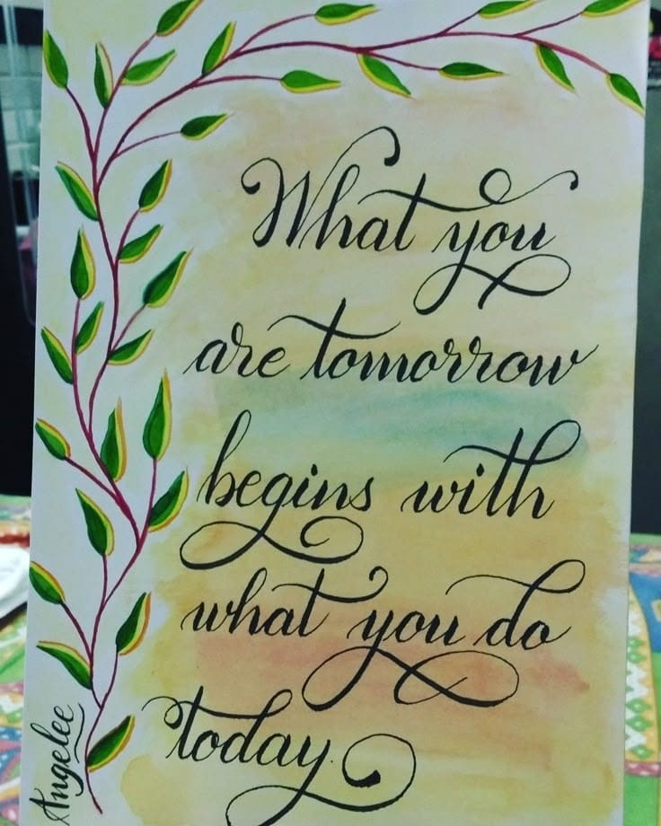

**Creativity corner :-**

**Prepare a Father’s day card, give it to your father and take a short video or pictures.**

1- Father' day Celebration on 15 June 2025

**Prepare a short video or take pictures related to any one activity**

1- Environmental day Celebration on 5 June 2025.

2- Use any recyclable material like - plastic , bottle, cardboard boxes, old C.D and make any craft material

3- Reuse rain water.

4- Plant any indoor or outdoor plant in your house.

5- Any ecofriendly activity to save mother earth.

6- Implant Any seed in soil and observe its growth.

**Perform any one activity and prepare a short video or take some pictures.**

1- International Yoga day Celebration on21 June 2025 2- Surya namaskar

3- Tadasana (Mountain Pose) 4- Vrksasana (Tree pose)

5- Bhujangasana (Cobra Pose)

6- Paschimottanasana (seated Forward bend)

**Note – (i) Revise the syllabus covered so far in every subject.**

**(ii) Use your subject notebook to solve question.**

**iii) 5 marks will be awarded in each subject in Periodic test-II for completing the holiday homework.**